Giuseppe Zanotti Releases Exclusive Collaboration
with Joe Flizzow and SonaOne

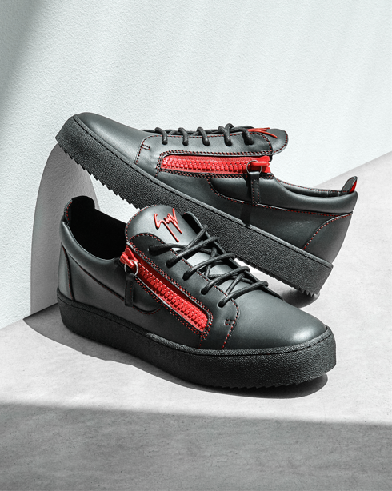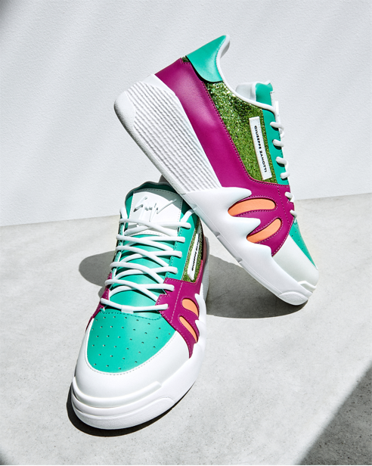

MALAYSIA – Leading Italian footwear designer Giuseppe Zanotti has designed an exclusive collection for Malaysia’s most influential rappers, Joe Flizzow and SonaOne, inspired by his love for music. The Italian designer, who started his career as a DJ may have swapped his turntables for sketchbooks, but music continues to be his most important source of inspiration.

A first of its kind, two limited edition male sneaker styles are based on Zanotti classics – the Frankie and the Talon.

The Frankie Noir low-top sneaker was reimagined for Joe Flizzow in all black version with fiery red logo, red contrast stitching and red zip fastenings on the either side, showcasing the rapper’s style in an elegant and elevated colourway.

“It is truly an honour to be working with Giuseppe. As a sneaker collector, I feel honoured to be able to share and see my vision transformed into reality. Put these shoes on in any city in the world and live your dreams to the fullest!”, said Joe Flizzow.

Embracing the free-spirit of hip hop, SonaOne customized the Bright Talon low-top sneakers with a bright multi-coloured fantasy, featuring glitter embellishments and complete with the Brand’s signature white rubber Talon sole.

“I have always been a fan and have connected with the Brand in ways that have given me a sense of familiarity and confidence. It’s a brand that allows one’s individuality to be expressed through its designs. To be a part of this collaboration with Signor Zanotti is truly a blissful moment of convergence between two creators, manifesting our imagination into the world for anyone who wishes to put their inner flair on display.”, said SonaOne.

“Working with Joe and Sonaone has been a refreshing experience. I really appreciated their specific point of view on fashion and style,” says Mr. Zanotti.

“We are proud to be part of this collaboration. Music and fashion have always gone hand in hand, and we are incredibly honoured that Mr. Zanotti has chosen to celebrate the music and culture of Malaysia with the creation of these innovative pieces,” says Mr. Sharan Valiram, Executive Director of Valiram.

Giuseppe Zanotti shoes have become a mainstay of red-carpet fashion, worn by celebrities including Madonna, Beyoncé, Lady Gaga, and Rihanna. Every pair of Giuseppe Zanotti shoe is hand-crafted in the Brand’s own factory in Italy.

The limited-edition styles are now available in limited quantities at the Pavilion Kuala Lumpur boutique and retail for RM3,590 and RM3,990 respectively.

Giuseppe Zanotti is honored to have the support of Universal Music Malaysia, DefJam Malaysia and DefJam South Sea Asia in making this collaboration between such talented men and artists come to life.

Please find below the link to high resolution images:
https://www.dropbox.com/sh/vbn35pf5rmzj19r/AACURD16m9w98BYOamq0P_7ia?dl=0

#GZMalaysia #Valiram

For further information please contact:

Aliana Roslan
Marketing Manager

Tel: 012-235 2055
Email: aliana.roslan@valiram.com

ABOUT GIUSEPPE ZANOTTI
Giuseppe Zanotti is an Italian luxury footwear and fashion designer known for his sculptural, jeweled heels and fashion forward sneakers. Through his eponymous label, Giuseppe Zanotti, the Italian-born Zanotti manufactures and distributes women’s, men’s and children’s shoes as well as small leather goods, handbags, jewelry and ready-to-wear. Available in 75 countries worldwide, Giuseppe Zanotti shoes are a red carpet favorite, inspired by and connected to the world of film, music and art.

ABOUT VALIRAM
Established in 1935, Valiram is Southeast Asia and Oceania’s leading fashion, lifestyle and luxury retail specialist with presence in Malaysia, Singapore, Indonesia, Australia, Philippines, Thailand, Macau, Vietnam and New Zealand. Operating more than 400 stores, the group represents international brands across various categories, from fashion and accessories, timepieces and jewellery, perfume and cosmetics to confectionery and F&B. Its portfolio comprises internationally renowned brands such as Michael Kors, Chloé, Steve Madden, Tumi, Tory Burch, Giuseppe Zanotti, Rolex, Bath & Body Works and Victoria’s Secret, as well as original and innovative retail concepts including Luxury Fashion, Swiss Watch Gallery, Flying Emporium and Beauty Love.

